目标

1. 实现运营商后台
   1. 查询待审核的app信息

1.2 实现APP审核功能

1. 运营商后台实现查询待审核的app信息

添加页面:查询所有开发者上传的待审核app信息

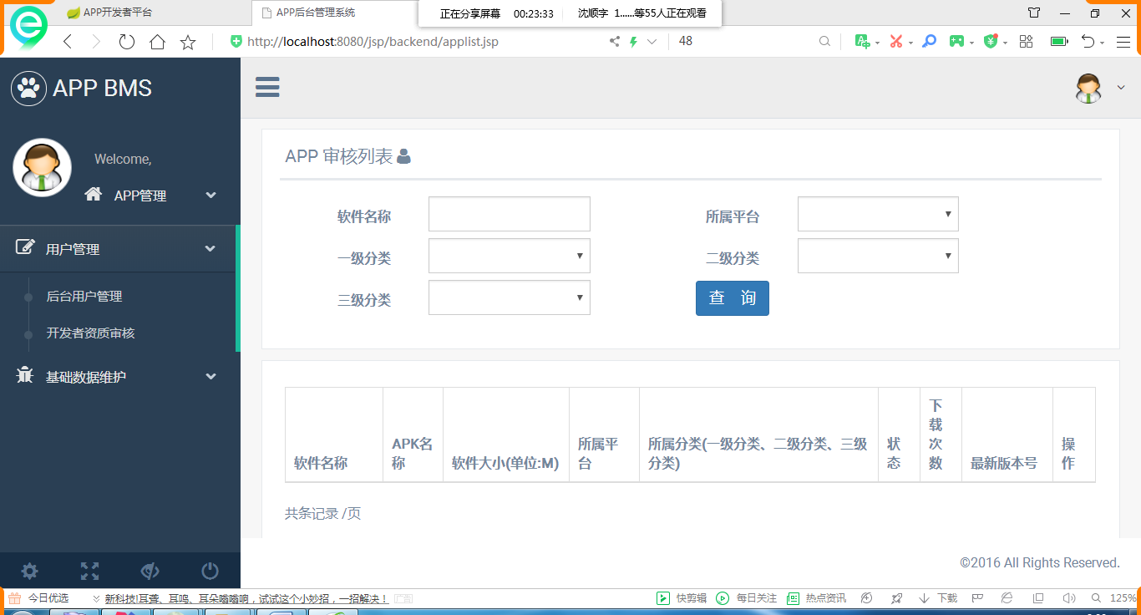

1. 编写dao层

接口:

|  |
| --- |
| *//查询所有待审核的app信息* List<AppInfo> getNoPassAppInfo(AppInfoCondition appInfoCondition); |

持久化操作:

|  |
| --- |
| *<!--查询待审核的app-->* <**select id="getNoPassAppInfo"  parameterType="com.team.appinfo.uitl.AppInfoCondition"  resultType="AppInfo"**>  SELECT  app_info.id,  softwarename,  softwaresize,  apkname,  downloads,  versionid,  status,  logopicpath,  (SELECT  valuename FROM `data_dictionary`  WHERE typename='所属平台'AND valueid=flatformId) AS ptname,  (SELECT valuename FROM `data_dictionary` WHERE typename='app状态'  AND valueid=STATUS) AS sname,  (SELECT categoryName FROM `app_category`  WHERE id=categoryLevel1) AS tname1  ,(SELECT categoryName FROM `app_category`  WHERE id=categoryLevel2) AS tname2  ,(SELECT categoryName FROM `app_category`  WHERE id=categoryLevel3) AS tname3  FROM app_info WHERE **STATUS=1**  <**if test="querySoftwareName!=null"**>  and softwarename like concat('%',#{querySoftwareName},'%')  </**if**>  <**if test="queryFlatformId!=null"**>  and FlatformId = #{queryFlatformId}  </**if**>  <**if test="queryCategoryLevel1!=null"**>  and CategoryLevel1 = #{queryCategoryLevel1}  </**if**>  <**if test="queryCategoryLevel2!=null"**>  and CategoryLevel2 = #{queryCategoryLevel2}  </**if**>  <**if test="queryCategoryLevel3!=null"**>  and CategoryLevel3 = #{queryCategoryLevel3}  </**if**> </**select**> |

1. 编写业务层

接口:

|  |
| --- |
| **public** PageInfo<AppInfo> getAllNoPassAppInfo(AppInfoCondition appInfoCondition); |

实现:

|  |
| --- |
| @Override **public** PageInfo<AppInfo> getAllNoPassAppInfo(AppInfoCondition appInfoCondition) {  *//1.开启分页* PageHelper.*startPage*(appInfoCondition.getPage(),appInfoCondition.getPageSize());  *//2.调用持久化操作查询所有* List<AppInfo> list=**appInfoMapper**.getNoPassAppInfo(appInfoCondition);  *//3.返回分页相关的信息* **return new** PageInfo<AppInfo>(list); } |

1. 编写控制层

|  |
| --- |
| *//发请求查询所有待审核的app信息* @RequestMapping(**"/noPassAppInfo"**) **public** String noPassAppInfo(AppInfoCondition condition, Model model){  *//调用业务  //1.查询app信息* PageInfo<AppInfo> pageInfo=**appInfoService**.getAllNoPassAppInfo(condition);  *//填充数据* model.addAttribute(**"pageInfo"**,pageInfo);  *//还原表单(实现查询条件的回显)* model.addAttribute(**"condition"**,condition);  **return "backend/applist"**; } |

1. 编写前端Jsp(复制原来的代码)
   1. 显示当前页的数据
   2. 加载条件表单中的数据
   3. 进行回显
   4. 制作分页导航
2. 实现App审核的显示页面🡪进行审核操作

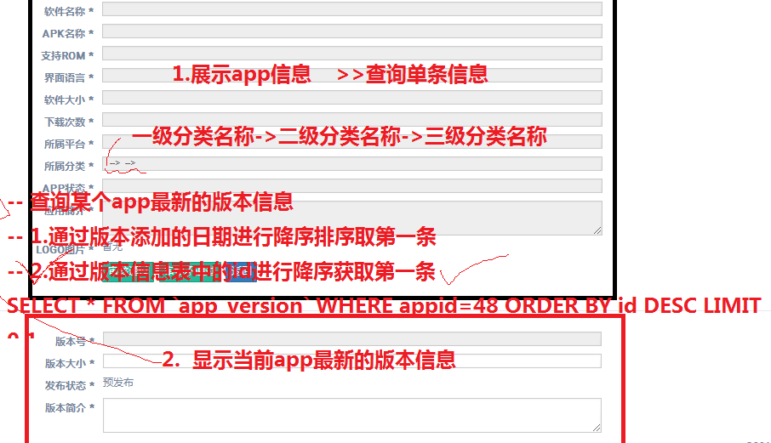

通过分析:

本页面需要显示当前app信息和app下最新版本信息

1. 编写查询单条app信息业务
   1. 编写Dao层

接口方法:

|  |
| --- |
| *//查询app信息关联状态名称、平台名称、分类名称* AppInfo selectByPrimaryKey3(@param(value=”appid”)Long id); |

持久化操作:查询一级分类名，二级分类名，三类分类名

|  |
| --- |
| *<!--查询app审核的信息-->* <**select id="selectByPrimaryKey3"  parameterType="long"  resultType="AppInfo"**> SELECT  app_info.id,  softwarename,  softwaresize,  apkname,  Supportrom,  downloads,  interfaceLanguage,  versionid,  STATUS,  logopicpath,  appinfo, (SELECT  valuename FROM `data_dictionary` WHERE typename='所属平台'AND valueid=flatformId) AS ptname,  (SELECT valuename FROM `data_dictionary` WHERE typename='app状态'  AND valueid=STATUS) AS sname,  (SELECT categoryName FROM `app_category`  WHERE id=categoryLevel1) AS tname1 ,(SELECT categoryName FROM `app_category`  WHERE id=categoryLevel2) AS tname2 ,(SELECT categoryName FROM `app_category`  WHERE id=categoryLevel3) AS tname3 FROM app_info where id=#{appid}  </**select**> |

* 1. 编写查询单条的业务

接口:

|  |
| --- |
| */**  * 查询app信息  \** ***@param id*** *编号  \** ***@return*** *app信息 关联状态名称、平台名称、分类名...  */* **public** AppInfo getAppInfo2(Long id); |

实现:

|  |
| --- |
| @Override **public** AppInfo getAppInfo2(Long id) {  **return appInfoMapper**.selectByPrimaryKey3(id); } |

1. 查询最新版的app信息业务
   1. 编写dao层 查询最新版本信息

接口:

|  |
| --- |
| *//查询最新的app版本信息 传的是app信息的id* AppVersion getLastVersionInfo(Long id); |

持久化操作:

|  |
| --- |
| *<!--查询最新的版本信息-->* <**select id="getLastVersionInfo" resultType="AppVersion" parameterType="long"**> SELECT id,versionInfo,versionSize,downloadLink,versioninfo, apkfilename, versionno, (SELECT valueName FROM data_dictionary WHERE typeName='发布状态'  AND valueId=publishStatus) AS pstatusname  FROM `app_version` WHERE appid=#{appid} ORDER BY id DESC LIMIT 0,1  </**select**> |

* 1. 编写业务层 在appversionservice业务中加

接口:

|  |
| --- |
| *//查询app最新的版本信息 传app信息的id* AppVersion getLastVersionByAppId(Long id); |

实现:

|  |
| --- |
| @Override **public** AppVersion getLastVersionByAppId(Long id) {  **return appVersionMapper**.getLastVersionInfo(id); } |

1. 编写控制器

|  |
| --- |
| *//查询后台待审核的app信息* @RequestMapping(**"/goAppCheck"**) **public** String goAppCheck(Long id,Model model){  *//1.调用业务获取app信息* AppInfo appInfo=**appInfoService**.getAppInfo2(id);  *//1.调用业务最新版本信息* AppVersion appVersion= **appVersionService**.getLastAppVersion(id);  *//2.将数据填充到作用域* model.addAttribute(**"appInfo"**,appInfo);  model.addAttribute(**"appVersion"**,appVersion);*//回显  //3.返加页面* **return "backend/appcheck"**; } |

1. 页面展示数据

略

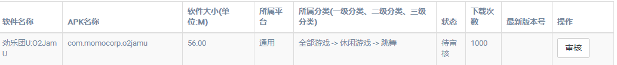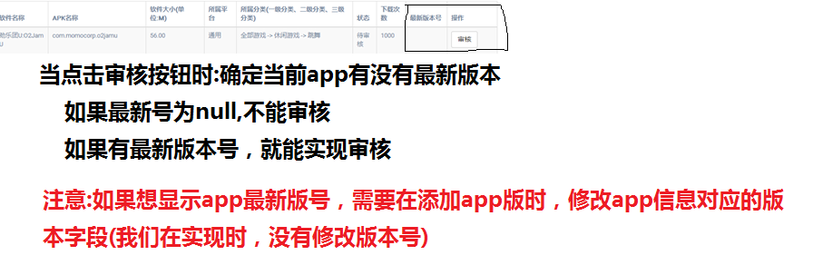

1. 使用jquery给审核按钮添加点击事件

|  |
| --- |
| <**button name="checkbutton" appid="${**appInfo.id**}" appversion="${**appInfo.versionno**}" type="button" class="btn btn-default checkApp"  data-toggle="tooltip" data-placement="top" title="" data-original-title="查看并审核APP"**>审核</**button**> |

1. 给按钮添加点击事件（使用jquery触发事件）

|  |
| --- |
| $(**function**(){  *//点击事件* $(**"[name='checkbutton']"**).click(**function**(){  *//获取当前按钮的属性值* **var** appid=$(**this**).attr(**"appid"**);  **var** appversion=$(**this**).attr(**"appversion"**);  **if**(appversion==**""**){  *alert*(**"当前app信息没有最新版本..不与审核");**  }**else**{  *//alert("审核");* ***location***.href=**"${**pageContext.request.contentType**}/goAppCheck?id="**+appid;  }  }); }); |